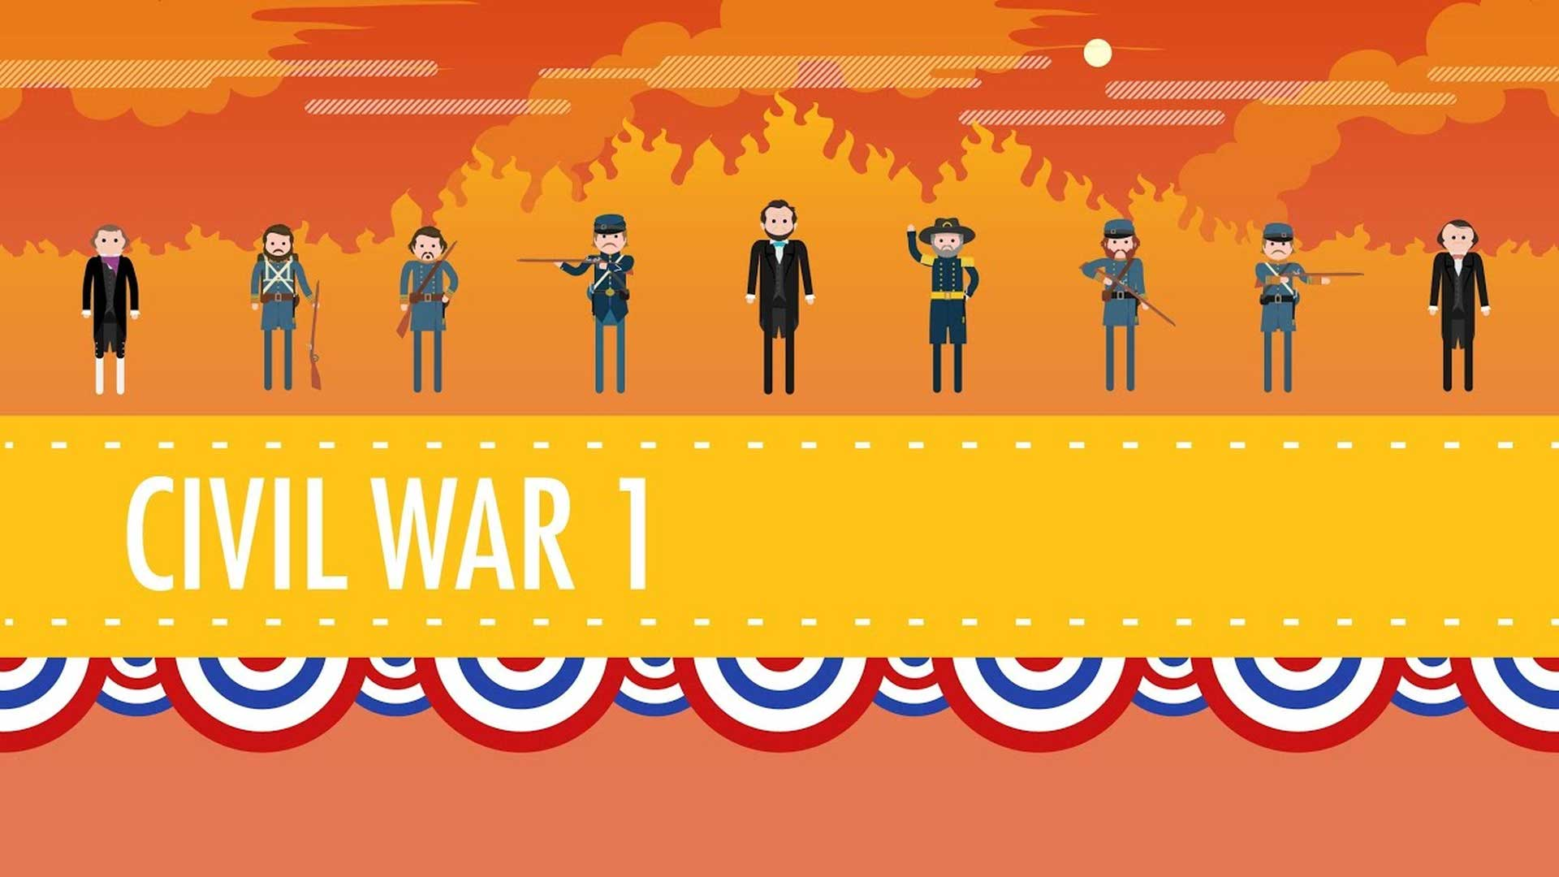

The Civil War, Part I: Crash Course US History #20
Term | Definition |  |  | Example Sentence
conflict (noun) | a serious disagreement or argument between two or more groups or individuals |  |  | The conflict between the North and the South led to the Civil War.
slavery (noun) | the practice of owning and controlling another person as property, often forcing them to work without pay |  |  | Many people fought against slavery during the Civil War.
resources (noun) | materials or assets that can be used to achieve a goal or accomplish a task |  |  | The Union had more resources, such as factories and railroads, which helped them in the war.
victory (noun) | a successful outcome or achievement, usually in a battle or competition |  |  | General Grant's strategies led to the Union's victory in the Civil War.
politics (noun) | activities, actions, and policies used to gain and hold power in a government or to influence the government |  |  | Politics played a role in determining the outcome of the Civil War.

The Civil War, Part I: Crash Course US History #20
The Civil War was a big conflict that happened in the United States from 1861 to 1865. It was fought between the North, called the Union, and the South, called the Confederate States of America. Some people think the war was mainly about slavery, while others have different ideas. President Lincoln said it was about keeping the country together. Religion was also important to both sides. The Union had more resources and eventually won the war. General Grant played a big role in the Union's victory. There were important battles like Gettysburg and the capture of Atlanta that helped the Union win. The war wasn't just won by battles, but also by politics. After the war, there were still questions that came up.

Reading Summary
- The Civil War was fought in the United States from 1861 to 1865.
- It was between the North (Union) and the South (Confederate States of America).
- The war had different reasons, including slavery and keeping the country together. The Union eventually won with the help of General Grant and important battles like Gettysburg and the capture of Atlanta.

Multiple Choice Questions
Question #1 |  | Question #2 |  | Question #3
When did the Civil War take place? |  | Who were the two sides that fought in the Civil War? |  | What was President Lincoln's view on the reason for the Civil War?
- From 1861 to 1865  - From 1776 to 1783  - From 1812 to 1815  - From 1914 to 1918 |  | - The Union and the Confederate States of America  - The North and the South  - The United States and Canada  - The East and the West |  | - He believed it was about keeping the country together  - He believed it was mainly about slavery  - He believed it was about religion  - He believed it was about gaining more resources

Short Answer Questions
Question #1 | When did the Civil War take place in the United States?
__________________________________________________________________________________________________________________________________________________________________________________________________________________________________________________________________________________________________________________________________________________________________________________
Question #2 | Who were the two sides that fought in the Civil War?
__________________________________________________________________________________________________________________________________________________________________________________________________________________________________________________________________________________________________________________________________________________________________________________
Question #3 | What was President Lincoln's view on the reason for the war?
__________________________________________________________________________________________________________________________________________________________________________________________________________________________________________________________________________________________________________________________________________________________________________________

Open Ended Questions
Question #1 | How do you think the Civil War impacted the lives of people living in the United States during that time?
__________________________________________________________________________________________________________________________________________________________________________________________________________________________________________________________________________________________________________________________________________________________________________________
Question #2 | Why do you think it is important for a country to stay united? How does this relate to your own life?
__________________________________________________________________________________________________________________________________________________________________________________________________________________________________________________________________________________________________________________________________________________________________________________
Question #3 | Can you think of any conflicts or disagreements in your own life that were resolved through politics rather than physical force? How did that make you feel?
__________________________________________________________________________________________________________________________________________________________________________________________________________________________________________________________________________________________________________________________________________________________________________________

This Diffit resource was created by Kane Pittard

